**PRE- MOCK SET 5 EXAMINATIONS, 2024**

**PRIMARY SEVEN SOCIAL STUDIES**

**Duration: 2 Hours 15 Minutes**

**NAME: ______________________________________________ STREAM: _________**

INDEX NO.

EMIS NO.

**SECTION A**

1. Mention one element of a good map.

………………………………………………………………………………………………......

1. Give the importance bore well to a community.

………………………………………………………………………………………………......

1. Mention one advantage of constructing storied buildings in towns.

………………………………………………………………………………………………......

1. Give one example of a man-made lake in Africa

………………………………………………………………………………………………......

1. Why was Tanzania able to attain her independence before Uganda and Kenya?

…………………………………………………………………………………………………

1. Mention one problem faced by farmers in hilly areas.

………………………………………………………………………………………………......

1. Give another name for temperate grasslands of South Africa.

………………………………………………………………………………………………......

1. Name one African country crossed by the Prime Meridian.

………………………………………………………………………………………………......

1. Give one importance of a school motto to school children.

………………………………………………………………………………………………......

1. Mention any one cause of famine in some areas of Uganda.

………………………………………………………………………………………………......

1. How does Kenya depend on River Nile?

…………………………………………………………………………………………………

1. Give one reason why some families don’t rear domestic animals.

……………………………………………………………………………………………….....

1. Name one African country which was not colonized.

…………………………………………………………………………………………………..

1. Why are coastal areas of East Africa usually warm?

………………………………………………………………………………………………......

1. Write EALA in full.

………………………….………………………………………………………………………………......

1. Mention one human activity which reduces rainfall.

………………………………………………………………………………………………......

1. Draw a map symbol of a railway line in the space below.

|  |
| --- |
|  |

1. How can lack of immunization lead to a low population in a country?

………………………………………………………………………………………………......

1. What are by-laws?

………………………………………………………………………………………………......

1. Mention one role of a child in a home.

………………………………………………………………………………………………......

1. State one value of lakes to man.

………………………………………………………………………………………………….

1. Mention any one way of choosing leaders.

…………………………………………………………………………………………………..

1. How did the 1967 Constitution affect kingdoms in Uganda?

………………………………………………………………………………………………......

1. How did the independence of Eritrea affect the location of Ethiopia?

………………………………………………………………………………………………......

1. Give one advantage of air transport over water transport.

………………………………………………………………………………………………......

1. In which direction do shadows appear in the morning?

………………………………………………………………………………………………......

1. Draw the tool early man used to skin animals after killing them.

|  |
| --- |
|  |

1. Mention any one example of a primary industry.

………………………………………………………………………………………………......

1. Which group of foreigners introduced slave trade in East Africa?

………………………………………………………………………………………………......

1. How does altitude affect climate?

…………………………………………………………………………………………………..

1. State any one importance of a dog in a home.

………………………………………………………………………………………………......

1. Name the main crop grown at Gezira Irrigation scheme.

………………………………………………………………………………………………......

1. What should a driver do after seeing the road sign drawn below?

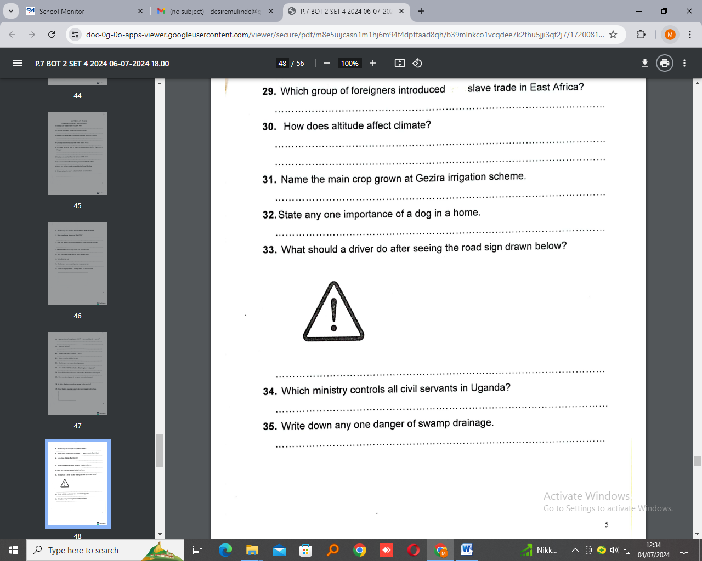…………………………………………………………………………………......

1. Which ministry controls all civil servants in Uganda?

………………………………………………………………………………………………......

1. Write down any one danger of swamp drainage.

………………………………………………………………………………………………......

**For questions 36 to 40, answer either Christianity or Islam but not both.**

1. **Either:**  Write one fruit of the Holy Spirit.

………………………………………………………………………………………………......

**OR:** Write one pillar of Islam.

………………………………………………………………………………………………......

1. **Either:**  Who was the earthly father of Jesus?

………………………………………………………………………………………………......

**OR:** Who was the father of Prophet Muhammad?

………………………………………………………………………………………………......

1. **Either:**  Give any one reason why Christian fear death.

………………………………………………………………………………………………......

**OR:** Give any one reason why Muslims fear death.

………………………………………………………………………………………………......

1. **Either:**  Write one duty of UJCC.

………………………………………………………………………………………………......

**OR:** Write one duty of UMSC.

………………………………………………………………………………………………......

1. **Either:**  Which angel brought good news to virgin Mary?

………………………………………………………………………………………………......

**OR:** Which angel revealed the Quran to Prophet Muhammad?

………………………………………………………………………………………………......

**SECTION B**

1. a) What is culture?

……….…………………....................................................……………………………….

b) Give two ways parents can help children to learn their culture.

i)…………………………………………………………………………………………………

ii)…………………………………………………………………………………………………

c) Mention one importance of culture.

..………………………………………………………………………………………………....

1. a) Which group of experts constructed the Uganda railway?

………………………………………………………………………………………………….

b) Mention any two reasons why the Uganda Railway was built.

i)…………………………………………………………………………………………………

ii)…………………………………………………………………………………………………

c) State one problem which was faced by the builders of the Uganda Railway.

…………………………………………………………………………………………………..

1. a) Write one importance of the fishing industry to a government.

..………………………………………………………………………………………………....

…………………………………………………………………………………………………

b) State one danger of over fishing.

…………………………………………………………………………………………………..

c) Mention any two traditional methods of fishing.

i)………………………………………………………………………………………………....

ii)…………………………………………………………………………………………………

1. a) Write LEGCO in full.

…………………………………………………………………………………………………

b) State any two reasons why LEGCO was formed.

i)..………………………………………………………………………………………………..

ii)………………………………………………………………………………………………

c) Which organ of a democratic government holds the same role today as LEGCO used to?

………………………………………………………………………………………………….

1. Study the map of Africa below and use it to answer the questions that follow.

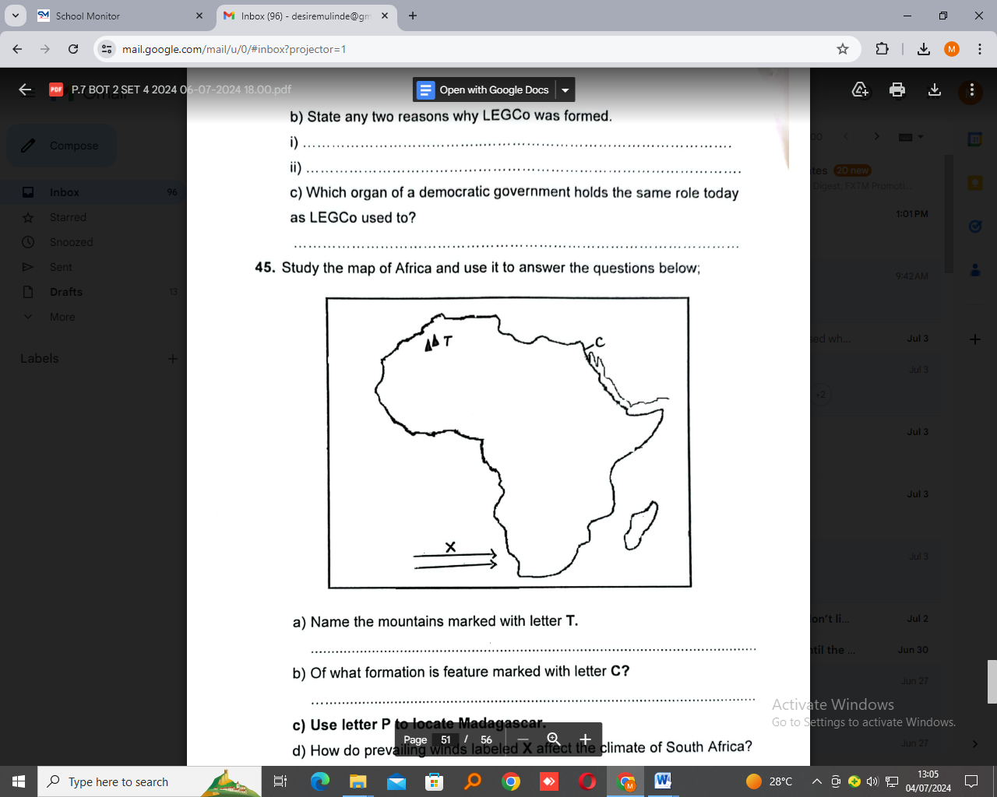

1. Name the mountain marked with letter T.

………………………………………………………………………………………………….

1. Of what formation is feature marked with letter C?

....………………………………………………………………………………………………..

c) Use letter P to locate Madagascar.

d) How do prevailing winds labeled X affect the climate of South Africa?

....………………………………………………………………………………………………..

1. a) Which vegetation zone covers the largest part of Uganda?

………………………………………………………………………………………………....

b) Mention any two economic activities carried out in Equatorial Rainforests of Africa.

i)………………………………………………………………………………………………....

ii)…………………………………………………………………………………………………

1. How do trees in desert regions survive hot and dry conditions?

…………………………………………………………………………………………………

1. a) Mention one way Local Government earns revenue.

…………………………………………………………………………………………………

b) Write in full.

i) CAO………….…………………………………………………………………………….

ii) RDC……………..…………………………………………………………………………..

c) What term is used to refer to the transfer of some powers from the Central Government to the Local Government?

………………………………………………………………………………………………….

1. a) What is industrialization?

………………………………………………………………………………………………....

b) How do rivers support industrialization?

…………………………………………………………………………………………………..

c) Mention two economic importance of industries.

i)………………………………………………………………………………………………....

ii)…………………………………………………………………………………………………

1. a) Which term is used to mean the total number of people in an area?

..………………………………………………………………………………………………....

b) Give any two factors which lead to population increase in an area.

i)………………………………………………………………………………………………....

ii)…………………………………………………………………………………………………

c) Write one disadvantage of a small population to traders.

…………………………………………………………………………………………………..

1. a) Identify one occasion where the Ugandan National Anthem is sung.

………………………………………………………………………………………………….

b) Why do Ugandans stand still while singing the Uganda National Anthem

…………………………………………………………………………………………………

c) Mention any two symbols of Uganda as a nation besides the Uganda national Anthem.

i)…………………………………………………………………………………………………

ii)…………………………………………………………………………………………………

**For questions 51 t0 55, answer either Christianity or Islamic but not both.**

1. **Either:** a) State any two miracles of Jesus besides raising the dead.

i)…………………………………………………………………………………………………

ii)…………………………………………………………………………………………………

b) Mention any one person Jesus raised back to life.

…………………………………………………………………………………………………..

c) State one reason why Jesus performed miracles.

…………………………………………………………………………………………………..

**OR:** a) Mention any two miracles which were performed by Prophet Muhammad.

i)…………………………………………………………………………………………………

ii)…………………………………………………………………………………………………

b) State any two reasons why Prophet Muhammad performed miracles.

i)…………………………………………………………………………………………………

ii)…………………………………………………………………………………………………

1. **Either:** a) What is a sin?

………………………………………………………………………………………………....

b) How did sin come to the world?

…………………………………………………………………………………………………..

c) Write any two ways Christians sin today.

i)…………………………………………………………………………………………………

ii)…………………………………………………………………………………………………

**OR:** a) What is a sin?

………………………………………………………………………………………………....

b) How did sin come to the world?

…………………………………………………………………………………………………..

c) Write any two ways Muslims sin today.

i)…………………………………………………………………………………………………

ii)…………………………………………………………………………………………………

1. **Either:** a) Who is an apostle?

………………………………………………………………………………………………....

b) Name the first two apostles of Jesus Christ.

i)…………………………………………………………………………………………………

ii)…………………………………………………………………………………………………

c) Why did Jesus choose apostles?

…………………………………………………………………………………………………

**OR:** a) Who is a caliph?

………………………………………………………………………………………………....

b) Mention any two caliphs of Prophet Muhammad..

i)…………………………………………………………………………………………………

ii)…………………………………………………………………………………………………

c) Give any one reason why Caliphs were chosen.

…………………………………………………………………………………………………

1. **Either:** a) Give any one way man uses each of the following body parts to worship God.

i) Eyes

………………………………………………………………………………………………….

ii) Mouth

…………………………………………………………………………………………………

iii) Hands

…………………………………………………………………………………………………

b) Mention one advantage of worshipping God.

………………………………………………………………………………………………....

**OR:** a) Give any one way Muslims uses each of the following body parts to worship Allah.

i) Eyes

………………………………………………………………………………………………….

ii) Mouth

…………………………………………………………………………………………………

iii) Hands

…………………………………………………………………………………………………

b) Mention one advantage of worshipping Allah.

………………………………………………………………………………………………....

1. **Either:** a) State the two greatest commandments according to Jesus.

i)…………………………………………………………………………………………………

ii)…………………………………………………………………………………………………

b) Give any two importance of the commandments of God to Christians.

i)…………………………………………………………………………………………………

ii)…………………………………………………………………………………………………

**OR:** a) Mention any two pillars of Islamic faith.

i)…………………………………………………………………………………………………

ii)…………………………………………………………………………………………………

b) Give any two ways a Muslim benefits from observing the pillars of Islamic faith.

i)…………………………………………………………………………………………………

ii)…………………………………………………………………………………………………

**END**